Open-source Alternatives to Famous Software
In this article, you'll be introduced to some impressive examples of FOSS (Free and Open-Source Software), which can be used as alternatives to some of the more well known closed-source and corporation-owned projects.

MS Office Suite, Google Docs: LibreOffice
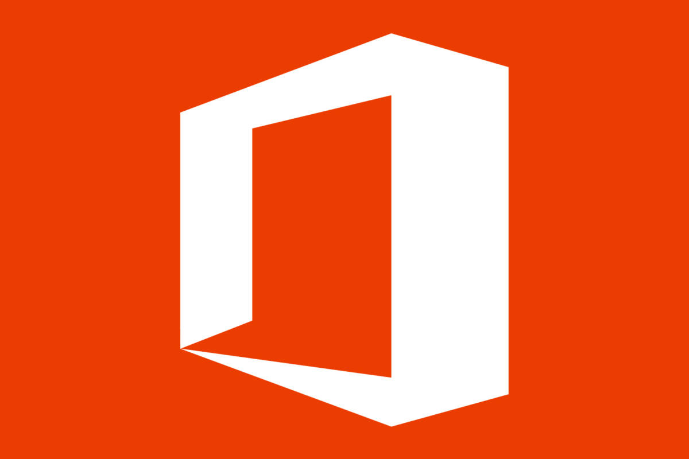


Microsoft Office is famous among document-editing software, and is by far the most commonly used. Google Docs, paired with the Google Drive storage system, is also immensely popular. On the other hand, few have heard of LibreOffice, let alone used it actively. LibreOffice was specifically developed for Linux users, as Microsoft has yet to develop Linux ports for many of their software. However, it can be used on any operating system.
A History of LibreOffice
When Microsoft Office was created in 2000, it had many competitors. These included StarOffice, then owned by Sun Microsystems. StarOffice was acquired and open-sourced by Oracle Corporation in 2009, and called Oracle OpenOffice. This project was considerably unsuccessful, however, and after concern over Sun Microsystem’s and later Oracle’s management of the project, the majority of OpenOffice developers left the project to start The Document Foundation (TDF). This organization created LibreOffice as a fork of the original Open Office. A year later (in 2012), Oracle sold the rights to OpenOffice, which had not been discontinued, to the Apache Software Foundation. Today there are two OpenOffices, LibreOffice and the original, LibreOffice being more popular.

Adobe Photoshop: GNOME GIMP



GNOME GIMP officially stands for GNU Network Object Model Environment GNU Image Manipulation Program. Since this abbreviation appeared, GNOME is not part of GNU (GNU’s Not Unix!), and, therefore, neither is GIMP. GIMP is the most powerful of the open-source image editing software in existence today, and is the most viable alternative to Adobe Photoshop. GIMP was created in 1998, 8 years after the initial release of Photoshop.

Twitter, Facebook, or any other social media you can think of:

Mastodon




Mastodon is an open-source social network maintained by the community. Instead of having all posts (called “toots” on Mastodon) on one website, anyone can host a Mastodon server similar to a group, called an “instance”, on their site. You can create an account with any instance, and instances can communicate with each other. For example, A user from one instance (e.g. FOSSTodon) can follow a user from another instance, or post on an instance other than the one where they had their account. Many people are starting to use Mastodon because of protection against racism and other forms of online abuse. Fact: Usernames in Mastodon are written “@user@instance.org” and Mastodon instances usually use either the “.org” or “.social” domains.

